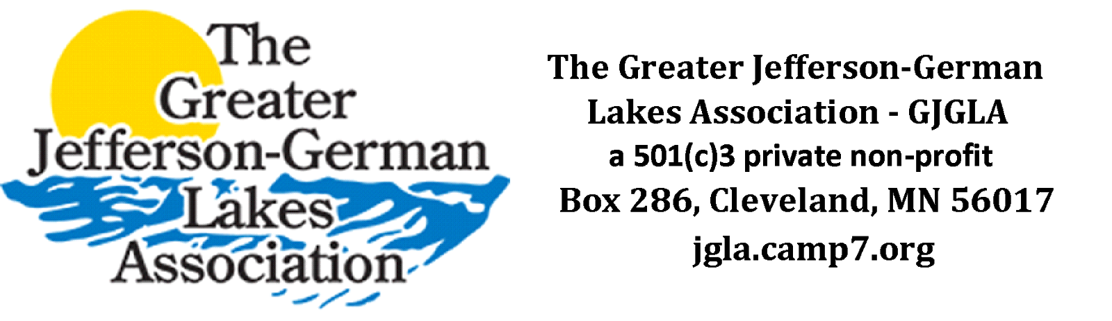

Board Meeting Minutes

Call to Order
A meeting of The Greater Jefferson-German Lakes Association was held online via Google Meet on September 6th, 2020.

Attendees
Attendees present include Dave, Sam, Lisa, and Ryan.

Members not in attendance
Members not in attendance include Ralph, Scott, and Bruce.

The meeting was called to order by the Vice President (Sam) at 11:06 AM
- Reappoint Sam and Scott to the board (3 year term)
  - Reappoint Sam: Dave made the motion, Lisa 2nd, All Approved
  - Reappoint Scott: Dave made the motion, Lisa 2nd, All Approved

- Discussion on Bruce as Board Member and his Membership has expired
  - Dave brought up a friend and former classmate that may be willing to take German Board Position if Bruce does not want to participate on Board
  - Must be a paying dues member to be a member of the Board
  - Discussion on the expectations and responsibilities of Board Members

- Language Options on the By-Law Changes
  - Sam made a motion to make the change to Option 1, Lisa 2nd, Approved
  - Board needs to Approve Amendment for Vote of Entire Membership
    - Need to reach out to all members (Facebook, Website, Emailing)
    - Only about 8 members that would need a mailing
    - Lisa is able to setup the ability to collect votes through Google Forum and the “We need your vote” verbiage
    - Possibly include in the mailing a Treasure’s Report, Historic Lake Level, Gentle reminder on Membership Renewal and what the dues go to, Possibility of an open Board Position, Dave’s copy of Geographical Formation of Jefferson-German Lakes
    - Dave will put together a piece on Geographical Formation of the lakes and the early settlers
    - Can send pictures of where the dues go
      - Ryan will send pictures of the Koppelman project on County Road 18 to Lisa
      - Lisa will ask Mike from Le Sueur County for a paragraph about the Koppelman project and prepare a piece with the photos for the mailing
    - Lisa will create a Google Doc that we will be editors of to avoid email strings
    - Discussion on the Newsletter Mailings from the past

- Sponsorship/Membership Renewal
    - Dave will contact Schmitt Masonry, Lawns R Us, and Summer Breeze
    - Sam will contact American Legion Post 311 and Stormy’s
    - Ryan will contact Dales Marine and Beaver Dam
    - Sponsors are getting free advertising at this point so their payment now will keep them active until May 1st, can give them a due date of two weeks to pay to keep their advertising active, Scott will be the one to remove the banner if needed
    - Can invite the Sponsors to send a Sponsor Profile (if they choose) to be shared on Facebook
    - Sam will write up the verbiage for a Membership Renewal to be given to Lisa to be posted on Facebook
    - Discussion on upcoming newsletter and (If Space Allows) the possibility of adding Sponsor Logos and/or ‘Thanks to Sponsors’ section

Adjournment

