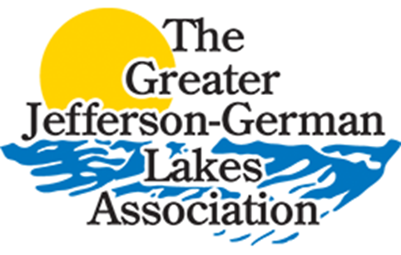
The Greater Jefferson-German
Lakes Association
GJGLA
Box 286, Cleveland, MN 56017
jgla.camp7.org

To: Landowners of East Jefferson, Middle Jefferson and West Jefferson Lakes of Le Sueur County.
Subject: 2022 Greater Jefferson German Lake Association - Lake Treatment Program
- The purpose of this information is to obtain a waiver of signatures due to the inability to contact all concerned. There are a lot of out of state owners plus many snowbirds who are still out of state. Also, if approved, we request a treatment pattern that is 100 feet from shore and extending to 150 feet from shore.
- This offshore lake treatment of the three lakes listed above will occur sometime in May or when the water warms to 50-55 degrees and on a calm day.
- The treatment will be for the control of Curly Leaf Pondweed and will be done from 100 to 150 feet from shore.
- The treatment will be done with an aquatic herbicide that has been proven not to harm humans, pets, fish or other aquatic species.
- The application will be made with a boat mounted drop system that applies the product on the lake bottom. This type of application lowers the possibility of drift to neighboring areas and provides control at the base of the plants.
- Landowners can request that the application not be done in front of their property. If you prefer not to participate, please notify Ryan Mattison at offshorelakejeffersonspraying@gmail.com and provide the landowners name, address and description of the property.

This program has been repeated for many years and has proven itself to be effective in gaining control of targeted species and improving water quality on the Jefferson German chain of lakes.

